**PRACTICAL NO 05**

**JDBC**

**a. Write a JDBC program that displays the data of a given table in a GUI Table**

import javax.swing.*;

import javax.swing.table.DefaultTableModel;

import java.awt.*;

import java.sql.*;

class DisplayTableData {

public static void main(String[] args) {

JFrame frame = new JFrame("Database Table Viewer");

frame.setDefaultCloseOperation(JFrame.EXIT_ON_CLOSE);

frame.setSize(600, 400);

JTable table = new JTable();

JScrollPane scrollPane = new JScrollPane(table);

frame.add(scrollPane, BorderLayout.CENTER);

// Default Table Model to manage data

DefaultTableModel model = new DefaultTableModel();

table.setModel(model);

try (Connection connection = DriverManager.getConnection("jdbc:mysql://localhost:3306/college", "root","");

Statement stmt = connection.createStatement();

ResultSet resultSet = stmt.executeQuery("SELECT * FROM student")) {

ResultSetMetaData metaData = resultSet.getMetaData();

int columnCount = metaData.getColumnCount();

for (int i = 1; i <= columnCount; i++) {

model.addColumn(metaData.getColumnName(i));

}

// Add data rows to the JTable model

while (resultSet.next()) {

Object[] row = new Object[columnCount];

for (int i = 1; i <= columnCount; i++) {

row[i - 1] = resultSet.getObject(i);

}

model.addRow(row);

}

} catch (SQLException e) {

JOptionPane.showMessageDialog(frame, "Error: " + e.getMessage(), "Database Error", JOptionPane.ERROR_MESSAGE);

e.printStackTrace();

}

frame.setVisible(true);

}

}

**OUTPUT:**

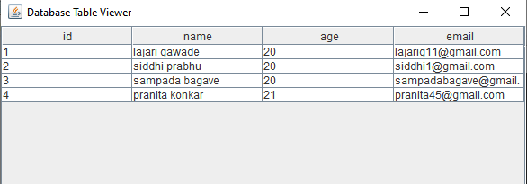

**b. Write a JDBC program to Show the details of a specified product from a given**

**table selected using Combobox.**

import java.sql.*;

import javax.swing.*;

import java.awt.*;

import java.awt.event.*;

class DataDemo implements ActionListener

{

JFrame f;

JComboBox b;

JLabel l;

JButton btn;

JTextArea txt;

Connection con;

ResultSet rs;

Statement st;

DataDemo()

{

f= new JFrame("Student Records");

f.setDefaultCloseOperation(JFrame.EXIT_ON_CLOSE);

f.setSize(500,500);

f.setLayout(new FlowLayout());

f.setVisible(true);

l=new JLabel("Product Details");

f.add(l,BorderLayout.NORTH);

txt=new JTextArea(10,20);

f.add(txt,BorderLayout.CENTER);

b=new JComboBox();

f.add(b,BorderLayout.CENTER);

btn=new JButton("Retrieve");

f.add(btn,BorderLayout.CENTER);

btn.addActionListener(this);

try

{

con=DriverManager.getConnection("jdbc:mysql://localhost:3306/product","root","");

Statement st=con.createStatement();

rs=st.executeQuery("select name from prod");

while(rs.next())

{

b.addItem(rs.getString("name"));

}

}

catch(SQLException e)

{

e.getMessage();

}

}

public void actionPerformed(ActionEvent a)

{

try

{

String val = (String) b.getSelectedItem();

//String val=b.getSelectedItem();

PreparedStatement ps=con.prepareStatement("select * from prod where name= ?");

ps.setString(1,val);

rs=ps.executeQuery();

while(rs.next())

{

txt.setText(" ");

txt.append(" ID :"+rs.getInt("id")+"\n");

txt.append(" Name :"+rs.getString("name")+"\n");

txt.append(" Price :"+rs.getInt("price")+"\n");

txt.append(" Quantity :"+rs.getInt("qty")+"\n");

}

}

catch(SQLException e)

{

e.getMessage();

}

}

public static void main(String args[])

{

DataDemo d=new DataDemo();

}

}

**OUTPUT:**

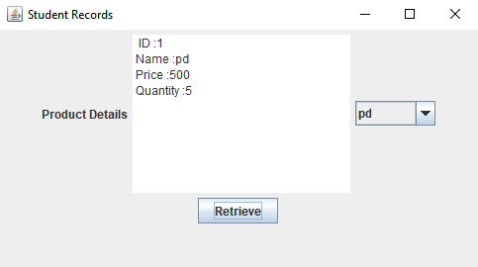

**c. Write a GUI application to Navigate forward and reverse result set data.**

import java.sql.*;

import javax.swing.*;

import java.awt.*;

import java.awt.event.*;

import java.util.*;

class Data implements ActionListener

{

JFrame f;

JLabel l;

JPanel p;

JButton nxt,prev;

JTextArea txt;

Connection con;

ResultSet rs;

Statement st;

Data()

{

f= new JFrame("Student Records");

f.setDefaultCloseOperation(JFrame.EXIT_ON_CLOSE);

f.setSize(500,500);

f.setLayout(new FlowLayout());

f.setVisible(true);

l=new JLabel("Student Details:");

f.add(l,BorderLayout.NORTH);

txt=new JTextArea(10,30);

f.add(txt,BorderLayout.CENTER);

p=new JPanel();

f.add(p,BorderLayout.SOUTH);

prev=new JButton("Previous");

p.add(prev,BorderLayout.SOUTH);

nxt=new JButton("Next");

p.add(nxt,BorderLayout.SOUTH);

prev.addActionListener(this);

nxt.addActionListener(this);

try

{

con=DriverManager.getConnection("jdbc:mysql://localhost:3306/college","root","");

Statement st=con.createStatement(ResultSet.TYPE_SCROLL_INSENSITIVE,ResultSet.CONCUR_READ_ONLY);

rs=st.executeQuery("select * from stud");

if(rs.next())

{

show();

}

}

catch(SQLException e)

{

e.getMessage();

}

}

public void show()

{

try

{

txt.setText(" ");

txt.append("ID :"+rs.getObject("id")+"\n");

txt.append("Name :"+rs.getObject("name")+"\n");

txt.append("Address :"+rs.getObject("add")+"\n");

txt.append("Class :"+rs.getObject("class")+"\n");

}

catch(SQLException e)

{

e.getMessage();

}

}

public void actionPerformed(ActionEvent a)

{

try

{

if(a.getSource()==prev)

{

if(rs.previous())

{

show();

}

else

{

txt.setText("No previous Records!!");

}

}

if(a.getSource()==nxt)

{

if(rs.next())

{

show();

}

else

{

txt.setText("No More Records!!");

}

}

}

catch(SQLException e)

{

e.getMessage();

}

}

public static void main(String args[])

{

Data d=new Data();

}

}

**OUTPUT:**

